Assignment No. 03
Title: AVL Tree with Rotations. Implement insertion and deletion operations in an AVL Tree. After each update, identify and display the rotation performed (LL, LR, RL, or RR).

Introduction:
AVL Tree:
- An AVL tree is a self-balancing Binary Search Tree where the height difference between left and right subtrees (balance factor) of every node is at most 1.
- After every insertion or deletion, rotations are performed to maintain balance, ensuring all operations (search, insert, delete) run in O(log n) time.

Structure of AVL Tree:
Each node in an AVL tree contains:
- Data (key value)
- Left child pointer
- Right child pointer
- Height (important for balance calculation)
So compared to a normal BST, AVL stores one extra field: height.

Types of Rotations Performed
- LL Rotation (Right Rotation):
Performed when a node becomes unbalanced due to insertion/deletion in the left subtree of its left child.
- RR Rotation (Left Rotation):
Performed when a node becomes unbalanced due to insertion/deletion in the right subtree of its right child.
- LR Rotation (Left-Right Rotation):
Performed when imbalance occurs in the right subtree of the left child, so first left rotation on left child then right rotation on root.
- RL Rotation (Right-Left Rotation):
Performed when imbalance occurs in the left subtree of the right child, so first right rotation on right child then left rotation on root.

Pseudocodes:
Insertion –
FUNCTION INSERT(root, data)
1. IF root == NULL THEN
RETURN CREATE(data)
2. IF data < root.data THEN
root.left = INSERT(root.left, data)
3. ELSE IF data > root.data THEN
root.right = INSERT(root.right, data)
4. b = BALANCE(root)
// LL Case
5. IF b > 1 AND data < root.left.data THEN
RETURN LL(root)
// RR Case
6. IF b < -1 AND data > root.right.data THEN
RETURN RR(root)
// LR Case
7. IF b > 1 AND data > root.left.data THEN
root.left = RR(root.left)
RETURN LL(root)
// RL Case
8. IF b < -1 AND data < root.right.data THEN
root.right = LL(root.right)
RETURN RR(root)
9. root.height = 1 + MAX(HEIGHT(root.left), HEIGHT(root.right))
10. RETURN root

Deletion –
FUNCTION DELETE(root, data)
1. IF root == NULL THEN
RETURN root
2. IF data < root.data THEN
root.left = DELETE(root.left, data)
3. ELSE IF data > root.data THEN
root.right = DELETE(root.right, data)
4. ELSE // Node found
IF root.left == NULL THEN
temp = root.right
DELETE root
RETURN temp
ELSE IF root.right == NULL THEN
temp = root.left
DELETE root
RETURN temp
temp = MIN_VALUE_NODE(root.right)
root.data = temp.data
root.right = DELETE(root.right, temp.data)
5. IF root == NULL THEN
RETURN root
6. root.height = 1 + MAX(HEIGHT(root.left), HEIGHT(root.right))
7. b = BALANCE(root)
// LL Case
8. IF b > 1 AND BALANCE(root.left) >= 0 THEN
RETURN LL(root)
// LR Case
9. IF b > 1 AND BALANCE(root.left) < 0 THEN
root.left = RR(root.left)
RETURN LL(root)
// RR Case
10. IF b < -1 AND BALANCE(root.right) <= 0 THEN
RETURN RR(root)
// RL Case
11. IF b < -1 AND BALANCE(root.right) > 0 THEN
root.right = LL(root.right)
RETURN RR(root)
12. RETURN root

Algorithms:
Insertion -
Step 1: If root is NULL, create a new node with given value and return it.
Step 2: If value is less than root.data, recursively insert into the left subtree.
Step 3: Else if value is greater than root.data, recursively insert into the right subtree.
Step 4: Update the height of the current node.
Step 5: Calculate Balance Factor
Balance = height(left subtree) − height(right subtree)
Step 6: If Balance > 1 and value < left child data
Perform Right Rotation (LL Case).
Step 7: If Balance < −1 and value > right child data
Perform Left Rotation (RR Case).
Step 8: If Balance > 1 and value > left child data
Perform Left Rotation on left child, then Right Rotation (LR Case).
Step 9: If Balance < −1 and value < right child data
Perform Right Rotation on right child, then Left Rotation (RL Case).
Step 10: Return the updated root.

Deletion -
Step 1: If root is NULL, return NULL.
Step 2: If value is less than root.data, delete from left subtree.
Step 3: Else if value is greater than root.data, delete from right subtree.
Step 4: Else (node found):
- If node has no child, Delete the node.
- If node has one child, Replace node with its child.
- If node has two children:
  - Find inorder successor (smallest in right subtree).
  - Copy successor value to current node.
  - Delete the successor.
Step 5: Update the height of current node.
Step 6: Calculate Balance Factor.
Step 7: If Balance > 1 and left subtree balance ≥ 0
Perform Right Rotation (LL Case).
Step 8: If Balance > 1 and left subtree balance < 0
Perform Left Rotation on left child, then Right Rotation (LR Case).
Step 9: If Balance < −1 and right subtree balance ≤ 0
Perform Left Rotation (RR Case).
Step 10: If Balance < −1 and right subtree balance > 0
Perform Right Rotation on right child, then Left Rotation (RL Case).
Step 11: Return updated root.

Flowcharts:
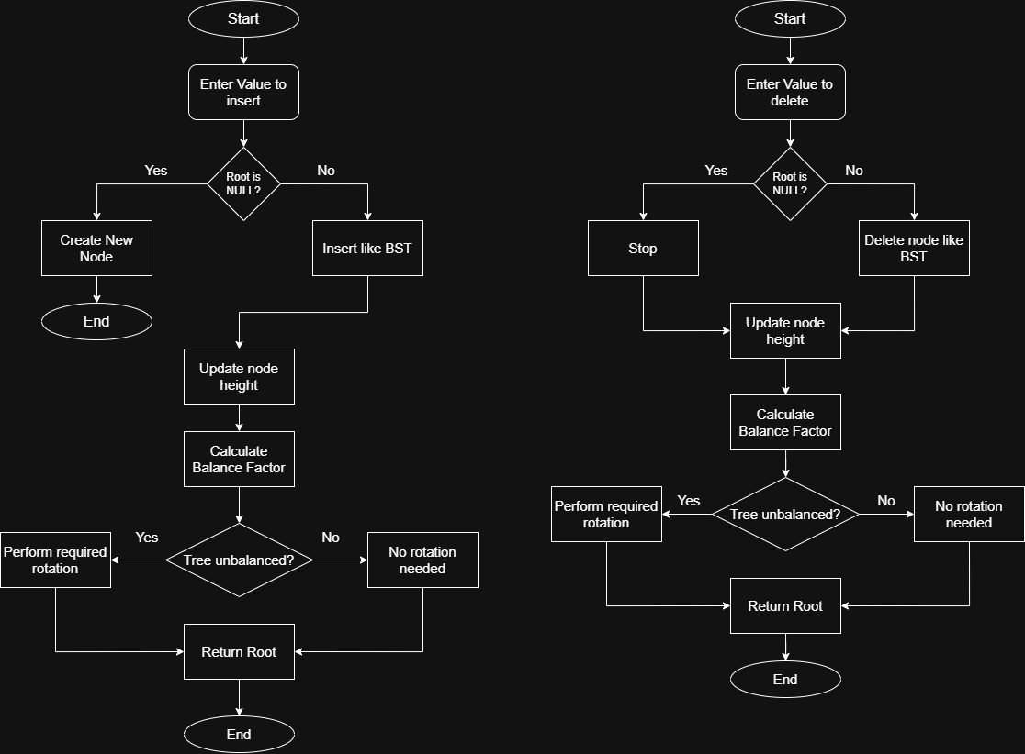
Fig 1 – Insertion in AVL Tree

Fig 2 – Deletion in AVL Tree

Codes:
AVLTree.cpp
#include <iostream>
using namespace std;
struct Node{
public:
int data;
Node* l;
Node* r;
int height;
};
Node* create(int data){
Node* root=new Node();
root->data=data;
root->l=NULL;
root->r=NULL;
root->height=1;
return root;
}
int height(Node* root){
return root==NULL ? 0 : root->height;
}
int balance(Node* root){
return root==NULL ? 0 : height(root->l)-height(root->r);
}
Node* LL(Node* root){
Node* x=root->l;
Node* y=x->r;

x->r=root;
root->l=y;

root->height=max(height(root->l),height(root->r))+1;
x->height=max(height(x->l),height(x->r))+1;
return x;
}
Node* RR(Node* root){
Node* x=root->r;
Node* y=x->l;

x->l=root;
root->r=y;

root->height=max(height(root->l),height(root->r))+1;
x->height=max(height(x->l),height(x->r))+1;
return x;
}
Node* insert(Node* root,int data){
if(root==NULL){
return create(data);
}
if(data<root->data){
root->l=insert(root->l,data);
}else if(data>root->data){
root->r=insert(root->r,data);
}
int b=balance(root);

if(b>1&&data<root->l->data){
cout << "Performing LL (Right) rotation" << endl;
return LL(root);
}

if(b<-1&&data>root->r->data){
cout << "Performing RR (Left) rotation" << endl;
return RR(root);
}

if(b>1&&data>root->l->data){
cout << "Performing LR rotation" << endl;
root->l=RR(root->l);
return LL(root);
}

if(b<-1&&data<root->r->data){
cout << "Performing RL rotation" << endl;
root->r=LL(root->r);
return RR(root);
}
root->height = 1 + max(height(root->l), height(root->r));
return root;
}
Node* minval (Node* node){
Node* curr = node;
while(curr->l != NULL){
curr = curr->l;
}
return curr;
}
Node* deleteN (Node* root, int data){
if(root == NULL) return root;
if(data < root->data){
root->l = deleteN(root->l, data);
}else if(data > root->data){
root->r = deleteN(root->r, data);
}else{
if(root->l == NULL){
Node* temp = root->r;
delete root;
return temp;
}else if(root->r == NULL){
Node* temp = root->l;
delete root;
return temp;
}
Node* temp = minval(root->r);
root->data = temp->data;
root->r = deleteN (root->r, temp->data);
}
if(root == NULL) return root;
root->height = 1 + max(height(root->l), height(root->r));
int b = balance(root);
if(b > 1 && balance(root->l) >= 0){
cout << "Performing LL (Right) rotation after deletion" << endl;
return LL(root);
}
if(b > 1 && balance(root->l) < 0){
cout << "Performing LR rotation after deletion" << endl;
root->l = RR(root->l);
return LL(root);
}
if(b < -1 && balance(root->r) <= 0){
cout << "Performing RR (Left) rotation after deletion" << endl;
return RR(root);
}
if(b < -1 && balance(root->r) > 0){
cout << "Performing RL rotation after deletion" << endl;
root->r = LL(root->r);
return RR(root);
}
return root;
}
void display(Node* root){
if(root!=NULL){
display(root->l);
cout<<root->data<<" ";
display(root->r);
}
}
int main(){
int data;
int c=0;
Node* root=NULL;
while(c!=4){
cout<<"Menu :"<<endl;
cout<<"1. Insert"<<endl;
cout<<"2. Delete"<<endl;
cout<<"3. Display"<<endl;
cout<<"4. Exit"<<endl;
cout<<"Enter your choice: "<<endl;
cin>>c;
switch(c){
case 1:
cout<<"Enter data to insert: "<<endl;
cin>>data;
root = insert(root, data);
break;
case 2:
cout<<"Enter data to delete: "<<endl;
cin>>data;
root = deleteN(root, data);
break;
case 3:
cout<<"AVL Tree: "<<endl;
display(root);
cout<<endl;
break;
case 4:
cout<<"Bye Bye"<<endl;
break;
default:
cout<<"Choose correct option"<<endl;
}
}
}

Outputs:
AVL Tree Insertion
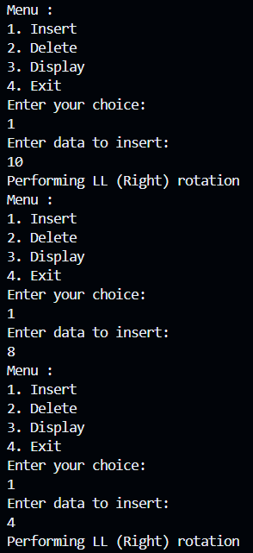

Display
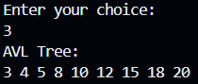

AVL Tree Deletion
